
EU DECLARATION OF CONFORMITY

1. PRODUCT:H2R ( MATRIX )
2. OBJECT OF THE DECLARATION: CHILDREN CAR 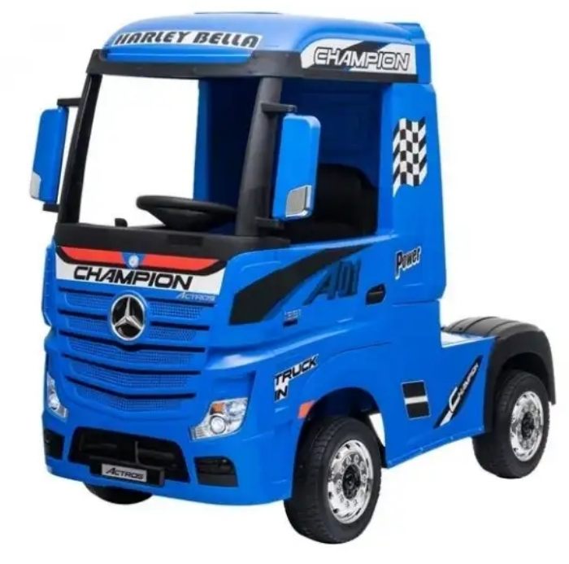
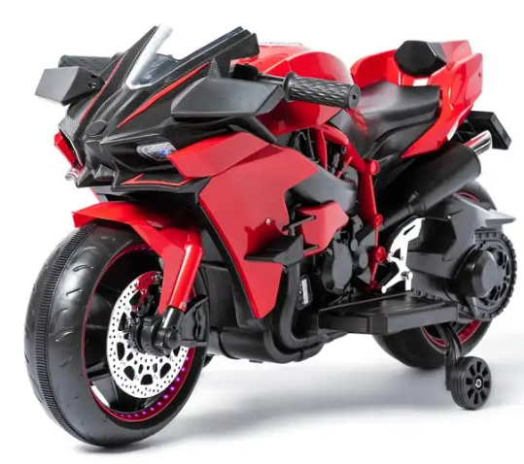
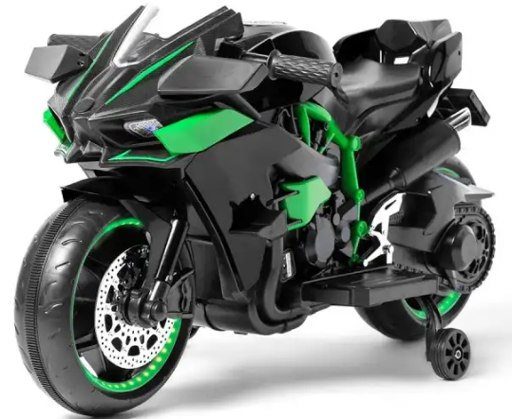
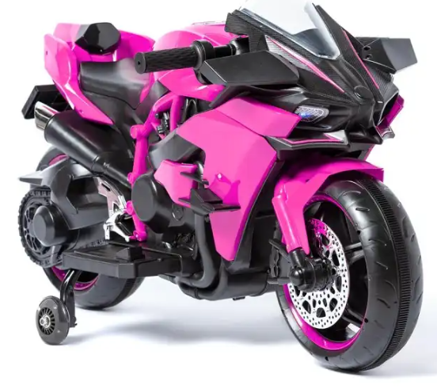

3. THE OBJECT OF THE DECLARATION DESCRIBED ABOVE IS IN CONFORMITY WITH THE RELEVANT EUROPEAN UNION HARMONISATION LEGISLATION:
2009/48/EC – SAFETY OF TOYS
2014/30/EU - EMC
EN 71-1 :2014+A1:2018
EN 71-2 :2020
EN 71-3 :2019+A1:2021
EN IEC 62115:2020+A11:2020

Ms Liu

